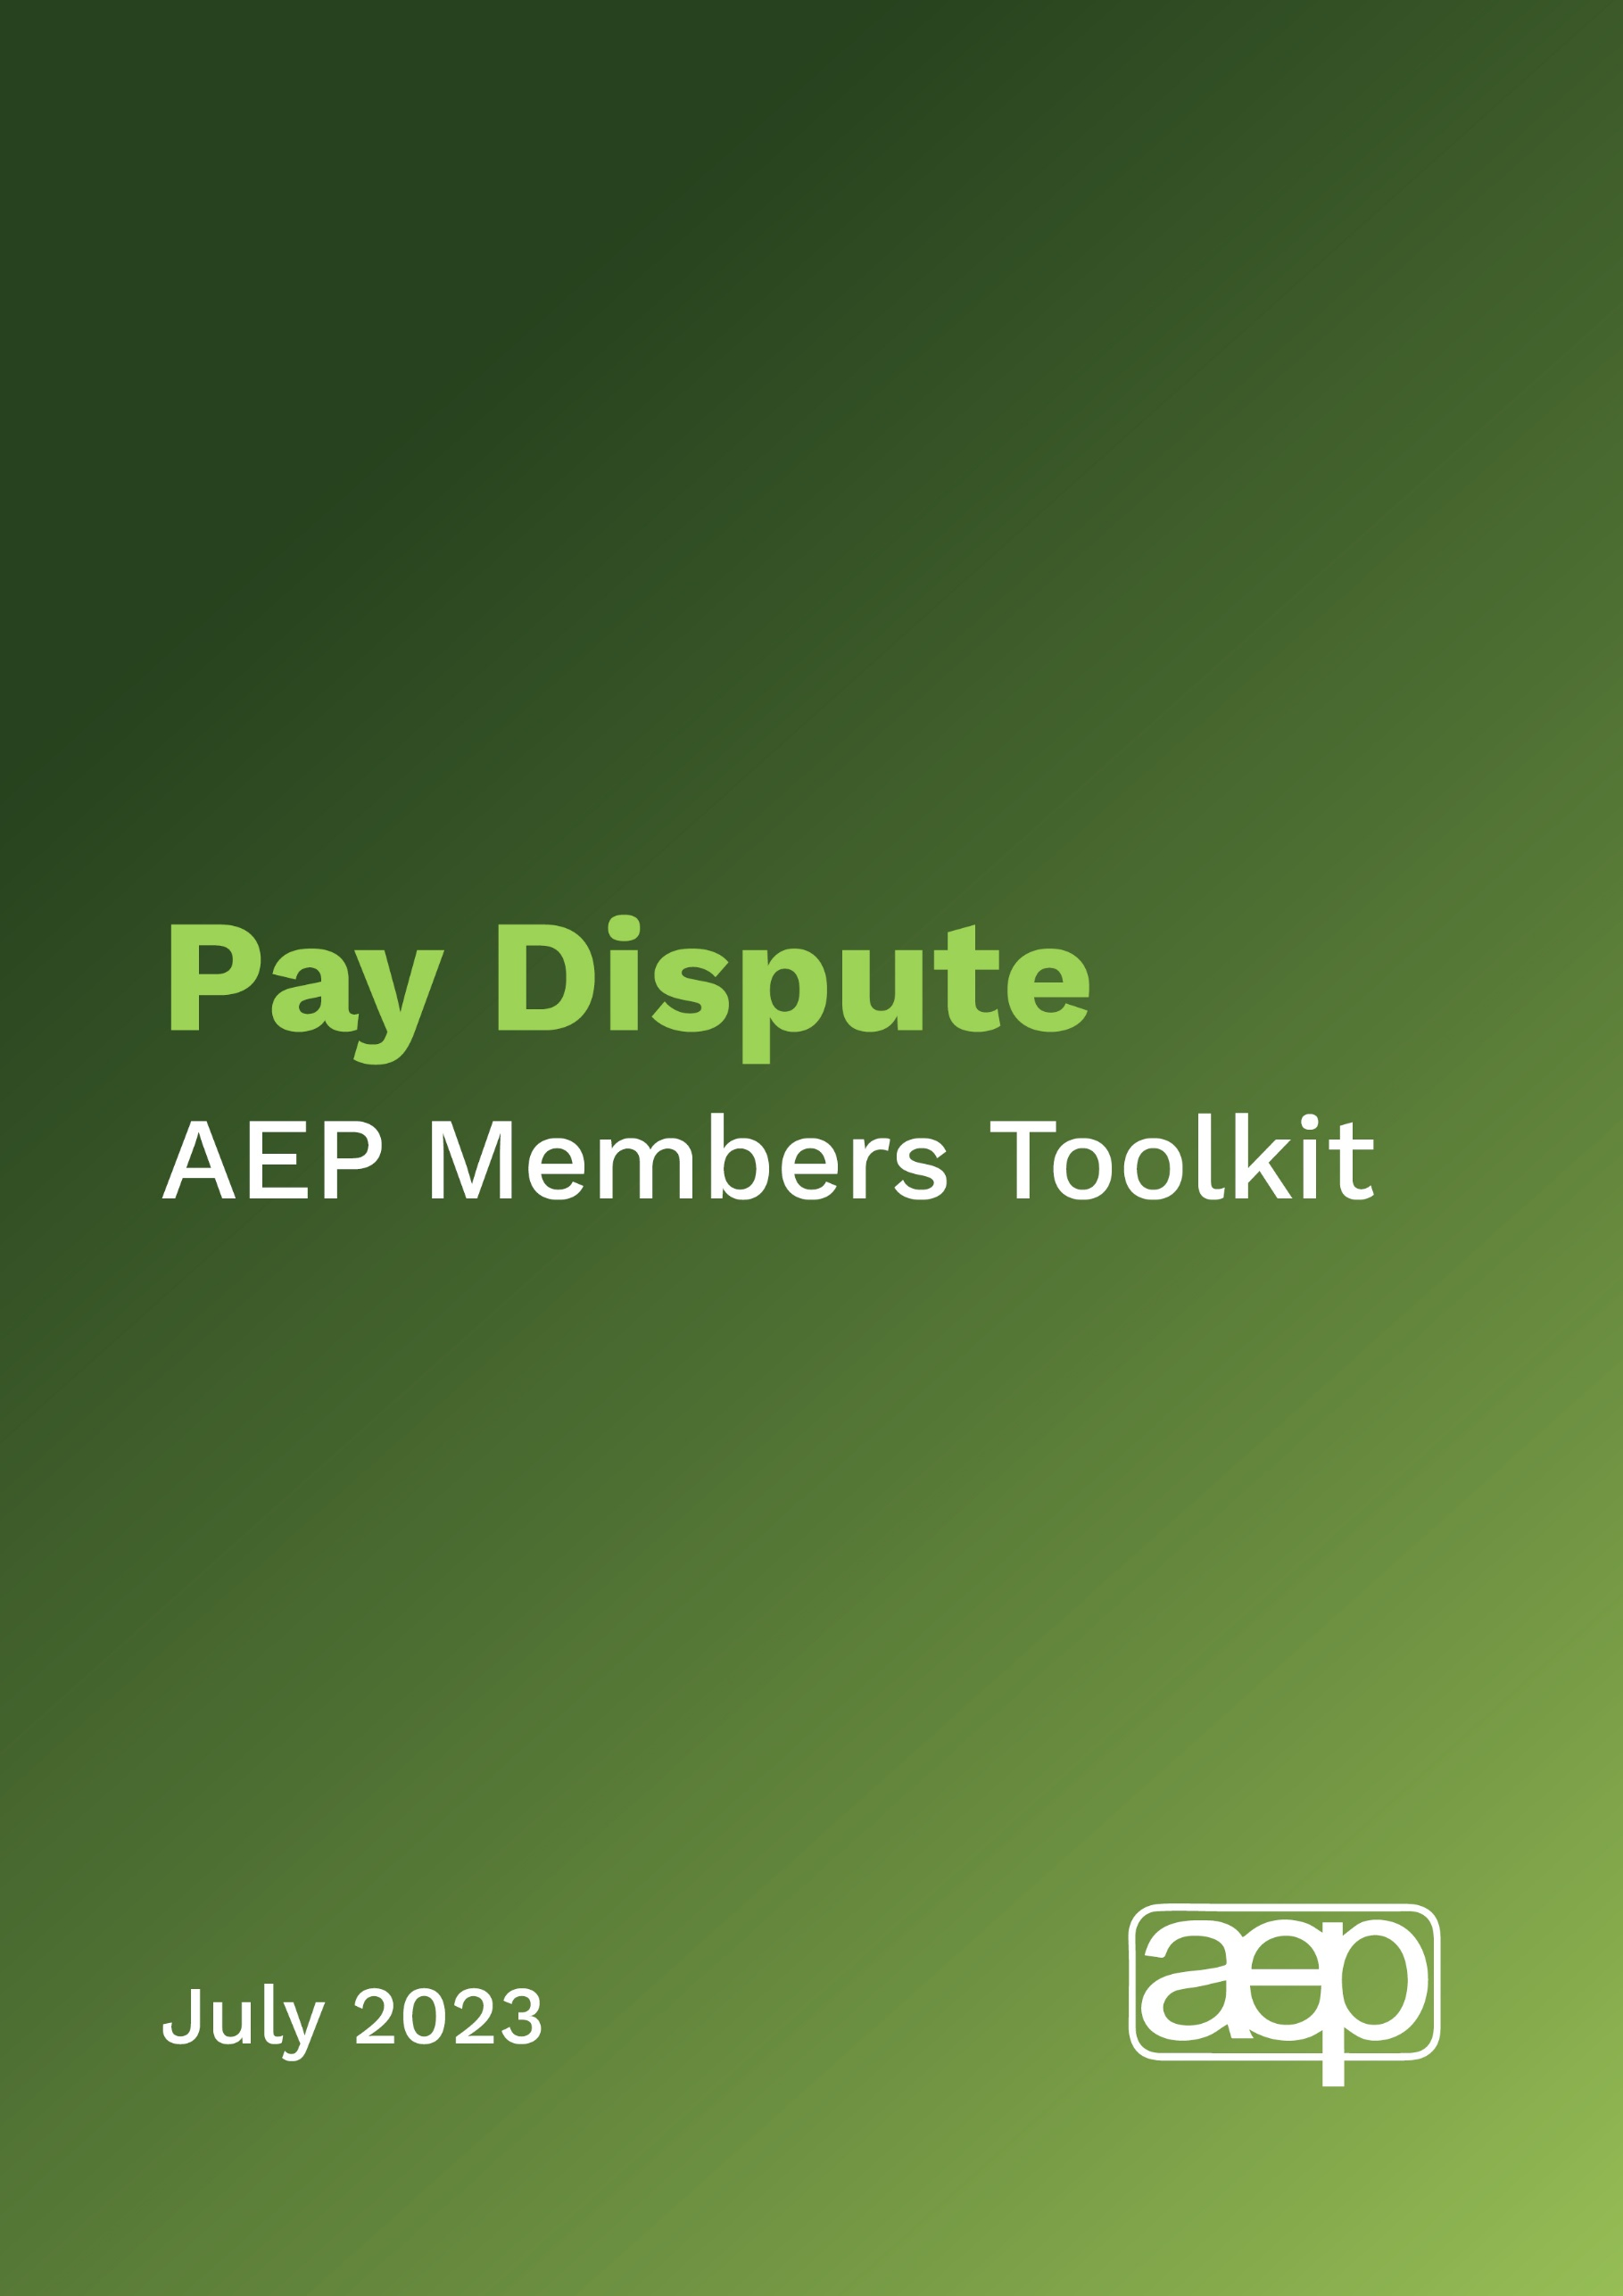
Pay dispute: AEP Members toolkit
Introduction

As you will be aware, the AEP has opened a formal ballot of members paid on Soulbury scales in local authorities, to decide whether to take industrial action in a pay dispute with local government employers. The AEP National Executive Committee are recommending that members vote ‘Yes’ to take industrial action.
The current pay offer of around 3% for most members would represent a real terms cut - at a time when inflation is running at 11.4%. It is also significantly lower than the pay settlements being agreed with other public sector workers. Worsening pay and conditions have led to a recruitment and retention crisis in services, with spiralling workloads leading to long wait times for children and young people in need of support.
Members support for our ballot for industrial action and our pay claim

We would appreciate members’ support to raise awareness of our current dispute with employers and the broader context of the significant challenges around workload and recruitment and retention in the profession.

We would like members to:
- Contact your local councillors to table the enclosed Council motion, if you do not live in the same local authority as you work
- Contact your local Council Leader if you do not live in the same local authority as you work (see letter template below)
- Contact your MP to ask for their support (see letter template below)
- Send a tweet, and/or like and share tweets from @AEPsychologists using the hashtag #SaveOurServices
- Raise the ballot and issues around EP pay in any appropriate professional or political forums that you are active in, including parent/carer forums – explain why we need to go on strike and help to challenge any negative narratives.
- Talk to the settings and families that you work with, where appropriate, so that they better understand the situation - and ask for their support to ensure the provision of quality services in the future.

You can find out who your local councillors are via the following link: WriteToThem - Email your Councillor, MP, MSP, MS, MLA or London Assembly Member for free

What’s in the toolkit?
This short toolkit is designed to provide easy to use resources for members to support the campaign. It contains:

- Background information
- Draft Council Motion
- Draft email/letter text to (i) local councillors and (ii) Council Leaders
- Draft email/letter text to your local MP
- Draft social media content
Background information

Educational Psychologists are in a pay dispute with employers, local authorities, represented by the Soulbury Committee, which is administered by the Local Government Association. After a decade in which real terms pay for Educational Psychologists has fallen, this year we are asking for a pay rise to fairly remunerate our members and help with recruitment and retention. The AEP, along with other Soulbury unions (the NEU and Prospect) submitted a claim for at least 9% on all pay points.

The employers’ side have made what they say is a ‘final offer’ of £1,925. This works out at between 2-5%, depending on EPs’ current pay, and on average is around a 3% offer. This represents a ‘real terms’ cut in pay at a time when inflation is above 10% and other public sector workers are being offered pay deals between 5-7%.

The AEP has only taken industrial action a few times in its history but we cannot go on seeing the erosion of pay and the erosion of services. Like other keyworkers, we have faced thirteen years of significant real terms pay cuts.
There is an acute shortage of educational psychologists in many local authority areas. Workforce figures suggest numbers are down from 1900 in 2010 to around 1530 by 2022. This is at a time of rising demand. There are too many Educational Psychologists leaving the local authority workforce, either leaving the profession or moving to locum or private work, and not enough being trained and entering the profession.

The workforce crisis has been confirmed by a new report from the Department for Education which reveals:
- 88% of local authorities reporting difficulties recruiting Educational Psychologists, with 48% citing pay as a key reason.
- A third of local authorities reporting difficulties with retention of Educational Psychologists.
- 69% of local authorities ‘not confident’ they will be able to meet the demand for educational psychologist services if there is no change in funding, training and service delivery models.
- 96% of those local authorities reporting recruitment and/or retention issues stated that these difficulties affected outcomes for children and young people requiring support.

The clearest indication of the increase in workload in England is around SEND and the number of Education, Health and Care Plans (EHCP), each of which requires statutory advice from an educational psychologist. The latest statistics show that there has been an increase in the percentage of pupils with EHCPs from 2.8% in 2016/17 to 4.3% in 2022/23, corresponding to an increase in the number of pupils with an EHCP (or SEN statements prior to the SEND reform) by 60.7%, (242,184 to 389,171). Similarly, the number of initial requests for an EHCP rose: from 64,555 to 114,457 during 2017 to 2022, representing an overall increase of 77.3% per cent.

In a recent survey of AEP members, 73% of those currently working as local authority employed EPs are considering leaving or reducing their hours to work privately, in the context of the rising cost of living and workload challenges.

DRAFT COUNCIL MOTION
[Council] notes the important role of Educational Psychologists (EPs) in supporting children, the recruitment and retention crisis in the profession, and the way this stems from the combination of underfunded services, workload pressures, and real terms cut to pay.
Council thanks the Educational Psychologists working for [Council] and across [area] for the vital work that they do to meet the needs of children and young people.
Council notes that there has been a 77.3% increase in demand for an Education, Health and Care Plan (EHCPs) over the past five years.

Council notes with concern that 88% of local authorities are reporting difficulties recruiting Educational Psychologists, with 48% citing pay as a key reason.

Council supports the Association of Educational Psychologists (AEP)’s call for fair pay as essential to recruitment and retention and to protect services for children and young people.

Council notes that the AEP has only taken industrial action a few times in its history and notes its decision to ballot for industrial action.

Council calls for more emphasis on and resources for early intervention and prevention support for children across the UK, including expanded access to specialists like EPs.
Council resolves to:
- Celebrate the unique and invaluable work of [Council]’s Educational Psychologists working with children and young people across [area].
- Work with the Association of Educational Psychologists to ensure proper investment in educational psychology services and to ensure that educational psychologists are fairly renumerated for the specialist job they do, and in order to recruit and retain the educational psychology workforce.
- Write to Rt Hon Gillian Keegan MP, Secretary of State for Education calling for greater investment in early intervention and prevention support.
- Make representations to the Local Government Association, as the Employer side in the current pay dispute with Educational Psychologists, to urge further negotiations.

LETTER/E-MAIL TO COUNCILLORS
Dear Cllr X,

Educational Psychologists

I am writing to you as a member of the Association of Educational Psychologists (AEP) and as an Educational Psychologist (EP) myself. As my local councillor, I would appreciate your support in making the case for investment in educational psychologists.

AEP is the professional association and trade union for 3,500 Educational Psychologists across the UK. EPs offer an essential service as a highly skilled workforce. We work collaboratively with many other professionals to provide expertise across the education sector, as well as offering a psychological understanding of education and child development. We seek to promote positive mental health and social wellbeing for all children and young people. We have specific expertise and statutory responsibilities regarding special educational needs and disabilities (SEND).

After months of increasing energy bills, inflation rises and higher interest rates we are in the throes of a cost-of-living crisis. It is essential that educational psychologists are fairly remunerated for the highly specialised job they do, and to recruit and retain the EP workforce. Had Educational Psychologists’ pay kept up with inflation, they would be receiving over £11,000 per annum more than they currently do. That represents a 17% ‘real terms’ pay cut since 2011.

The AEP has only taken industrial action a few times in its history, but it cannot go on seeing the erosion of pay and the erosion of services. Like other keyworkers, EPs have faced thirteen years of significant real terms pay cuts.
Poor pay and conditions have resulted in an unprecedented recruitment and retention crisis, as workloads spiral, and our wellbeing and the quality of services suffer.
These recruitment and retention problems matter to children and their families – years of under-recruitment and high leaving rates result in more demand for educational psychology services than can currently be met. This has led to psychologists being on the Government’s list of shortage occupations.
Staffing shortages mean that many local authorities are not able to meet the needs of these children and young people. Local authority educational psychology services are now at the brink.

That is why the AEP is now balloting for industrial action both in the interests of our members, in terms of their pay, conditions and workload, and the interests of the children, families and education professionals who are not able to access the educational psychology advice and support they need.
I would be very grateful if you could consider lending your support by tabling the enclosed Council motion.
Thank you in advance for your time, and I look forward to hearing from you. If you would like any further information about the AEP, please do let me know.

Best wishes,

[Name]
[Address]

LETTER/E-MAIL TO COUNCIL LEADERS

Dear Cllr X,

Educational Psychologists

I am writing to you as a member of the Association of Educational Psychologists (AEP) and as an Educational Psychologist (EP) myself. As Council Leader for [area], I would appreciate your support in making the case for investment in educational psychologists.

AEP is the professional association and trade union for 3,500 Educational Psychologists across the UK. EPs offer an essential service as a highly skilled workforce. We work collaboratively with many other professionals to provide expertise across the education sector, as well as offering a psychological understanding of education and child development. We seek to promote positive mental health and social wellbeing for all children and young people. We have specific expertise and statutory responsibilities regarding special educational needs and disabilities (SEND).

After months of increasing energy bills, inflation rises and higher interest rates we are in the throes of a cost-of-living crisis. It is essential that educational psychologists are fairly remunerated for the highly specialised job they do, and to recruit and retain the EP workforce. Had Educational Psychologists’ pay kept up with inflation, they would be receiving over £11,000 per annum more than they currently do. That’s represents a 17% ‘real terms’ pay cut since 2011.

The AEP has only taken industrial action a few times in its history, but it cannot go on seeing the erosion of pay and the erosion of services. Like other keyworkers, EPs have faced thirteen years of significant real terms pay cuts.
Poor pay and conditions have resulted in an unprecedented recruitment and retention crisis, as workloads spiral, and our wellbeing and the quality of services suffer.
These recruitment and retention problems matter to children and their families – years of under-recruitment and high leaving rates result in more demand for educational psychology services than can currently be met. This has led to psychologists being on the Government’s list of shortage occupations.
Staffing shortages mean that many local authorities are not able to meet the needs of these children and young people. Local authority educational psychology services are now at the brink.

That is why the AEP is now balloting for industrial action both in the interests of our members, in terms of their pay, conditions and workload, and the interests of the children, families and education professionals who are not able to access the educational psychology advice and support they need.
Educational Psychologists pay is negotiated with the Soulbury Committee, which is co-ordinated by the Local Government Association. I would very much appreciate it if you would write to the following key office holders at the LGA and DfE, to raise the issues in my letter and encourage them to agree a fair pay rise.

- Cllr Shaun Davies, Chair of the Local Government Association
- Cllr Izzi Seccombe is the Leader of Warwickshire County Council and the Leader of the Conservative Group on the Local Government Association.
- Mark Lloyd, CEO of the Local Government Association
- Secretary of State for Education, Rt Hon Gillian Keegan MP (emphasising the recruitment and retention challenges for the EPs workforce)

Thank you in advance for your time, and I look forward to hearing from you. If you would like to meet with representatives of the AEP, please do let me know.

Best wishes,

[Name]
[Address]

LETTER TO YOUR LOCAL MP
Dear [MP],

Educational Psychologists

I am writing to you as a member of the Association of Educational Psychologists (AEP) and as an Educational Psychologist (EP) myself. As my local Member of Parliament, I would appreciate your support in making the case for investment in educational psychologists.

AEP is the professional association and trade union for 3,500 Educational Psychologists across the UK. EPs offer an essential service as a highly skilled workforce. We work collaboratively with many other professionals to provide expertise across the education sector, as well as offering a psychological understanding of education and child development. We seek to promote positive mental health and social wellbeing for all children and young people. We have specific expertise and statutory responsibilities regarding special educational needs and disabilities (SEND).

After months of increasing energy bills, inflation rises and higher interest rates we are in the throes of a cost-of-living crisis. It is essential that educational psychologists are fairly remunerated for the highly specialised job they do, and to recruit and retain the EP workforce. Had Educational Psychologists’ pay kept up with inflation, they would be receiving over £11,000 per annum more than they currently do. That’s a 17% ‘real terms’ pay cut since 2011.

The AEP has only taken industrial action a few times in its history, but it cannot go on seeing the erosion of pay and the erosion of services. Like other keyworkers, EPs have faced thirteen years of significant real terms pay cuts.
Poor pay and conditions have resulted in an unprecedented recruitment and retention crisis, as workloads spiral, and our wellbeing and the quality of services suffer.
These recruitment and retention problems matter to children and their families – years of under-recruitment and high leaving rates result in more demand for educational psychology services than can currently be met. This has led to psychologists being on the Government’s list of shortage occupations.
Staffing shortages mean that many local authorities are not able to meet the needs of these children and young people. Local authority educational psychology services are now at the brink.

That is why the AEP is now balloting for industrial action both in the interests of our members, in terms of their pay, conditions and workload, and the interests of the children, families and education professionals who are not able to access the educational psychology advice and support they need.
I would be very grateful if you could consider lending your support by writing to:
- The Secretary of State for Education, Rt Hon Gillian Keegan MP (emphasising the recruitment and retention challenges for the EPs workforce)
- Mark Lloyd, Chief Executive of the Local Government Association, representing ‘the employers’ in the current pay dispute, to urge further negotiations take place.
Thank you in advance for your assistance and I look forward to hearing from you. If you would like any further information about the AEP, please do let me know.

Best wishes,

[Name]
[Address]

Suggested social media content:

- Children, young people & communities are suffering as result of years of underfunded services & poor pay – leading to a recruitment & retention crisis – and crippling workloads. EPs, please #VoteYes to #SaveOurServices
- We need Educational Psychologists in our communities. After 13 years of real terms pay cuts, Educational Psychologists call for fair wages #VoteYes #SaveourServices #TwitterEPs

- I’m supporting the @AEPsychologists ballot for industrial action - to stop the erosion of services for children and young people #VoteYes #SaveourServices #TwitterEPs

- Poor pay and conditions have resulted in an unprecedented recruitment crisis and local educational psychology services are now at the brink #VoteYes #SaveourServices #TwitterEPs

- The current pay offer for Educational Psychologists represents a 5.7% pay cut against the rate of inflation – we need fair pay to keep our services running for children & young people #VoteYes #SaveourServices #TwitterEPs

Further information
More information about AEP can be found on our website: https://aep.org.uk
If you have any further questions about making contact with your Councillor or MP, please contact Connect, AEP’s Westminster based team on aep@connectpa.co.uk

For more general queries, if you haven’t received your ballot paper yet, or you have questions about the ballot, please email enquiries@aep.org.uk

Educational psychology services: workforce insights and school perspectives on impact (publishing.service.gov.uk)

